Case 19-AM,C-Taino-Mask-Anthropomorphic-Vesicular Andesite

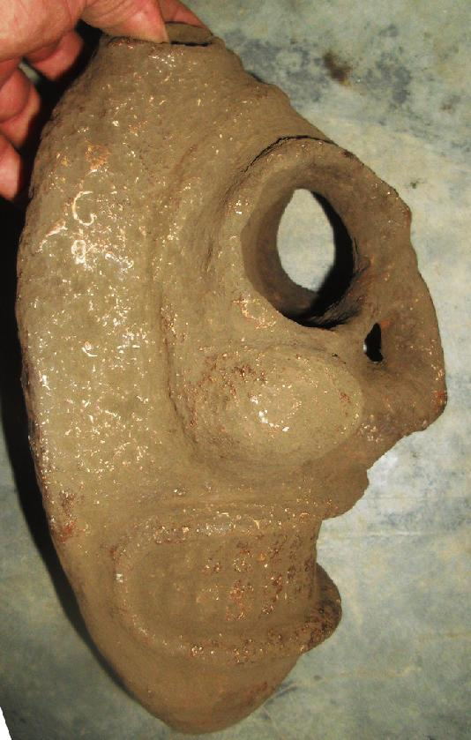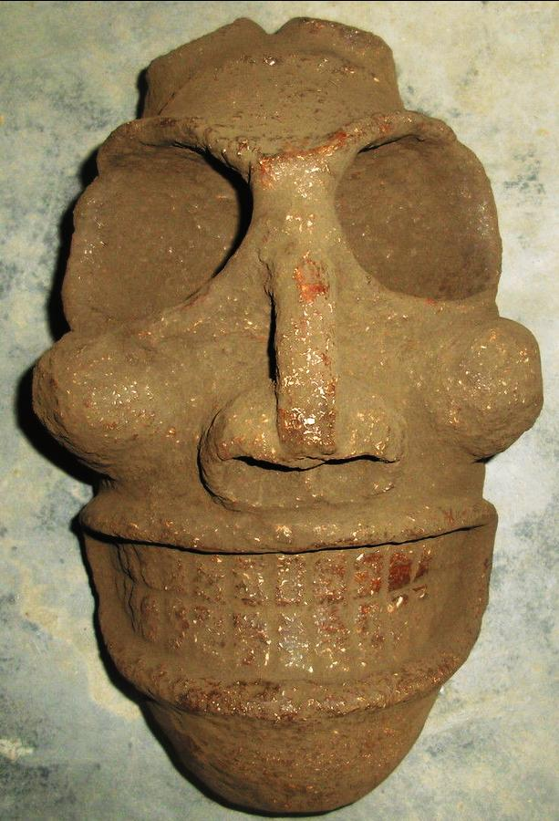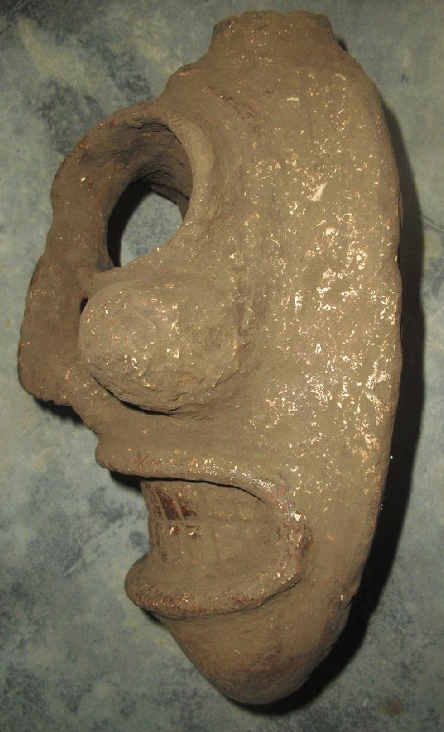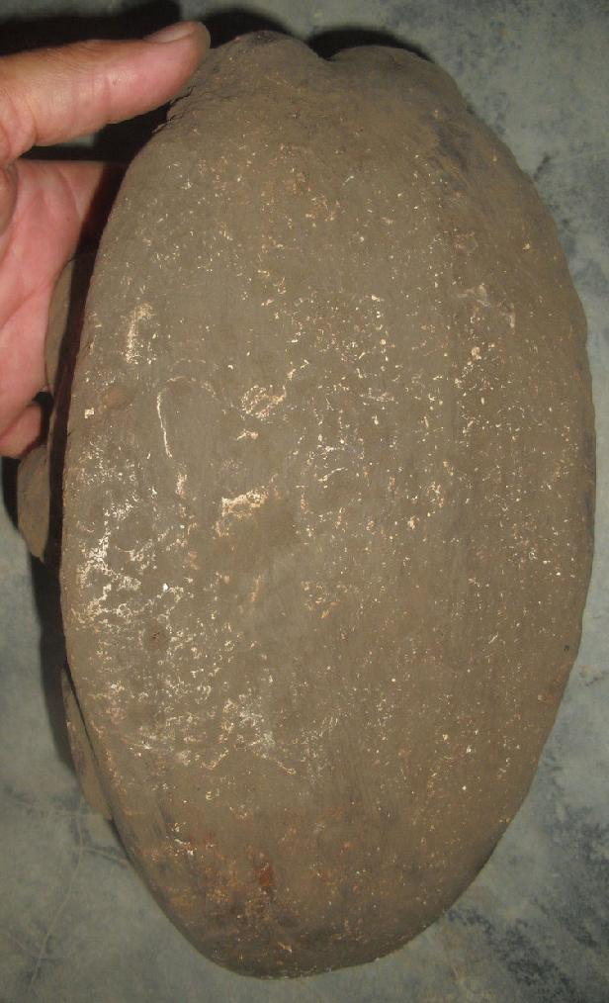

Delivery package 1 of 1
Estimated delivery Friday, Apr 29, 2016 - Wednesday, May 18, 2016
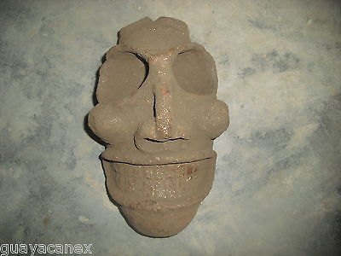

Taino head of stone
Item price | $399.00
Quantity | 1
Item number | 331798108152
Shipping service | Economy Shipping
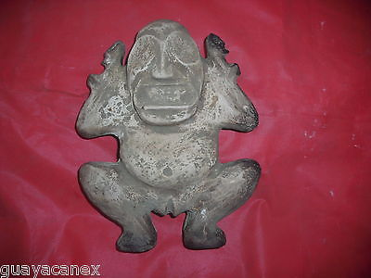

Taino Zemi of stone/mother earth in excellent condition
Item price | $199.00
Quantity | 1
Item number | 331798113138
Shipping service | Economy Shipping

Shipping address

Ralph J Coffman Jr
149 Atlantic Ave
Swampscott MA 01907-2427
United States

Order total

Subtotal | $598.00
Shipping | Free
Total
$598.00

Order placed on
Wednesday, Mar 16, 2016
Payment method
PayPal
Payment date
Wednesday, Mar 16, 2016

